
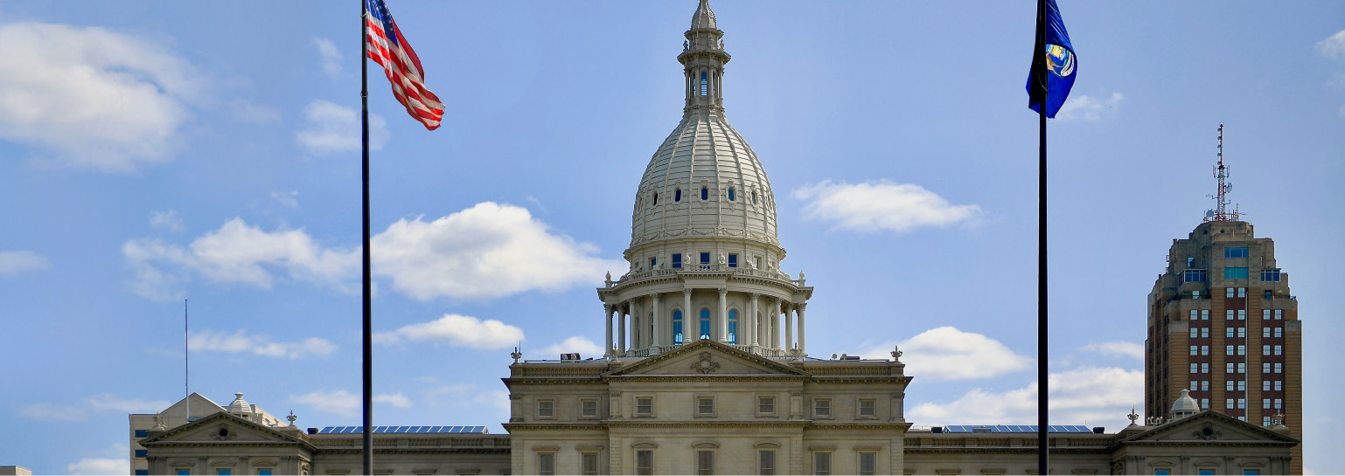

AESLC Legislative Day Sponsor Form
The Architects, Engineers, and Surveyors Legislative Committee (AESLC) is seeking firms and related businesses to sponsor the Reception with Michigan Legislators on the evening of April 30. Sponsorships are $350. Your firm will receive recognition during the webinar attended by participants and sponsor signage will be prominently displayed during the Legislator Reception.
Sponsoring Firm: Business address, city, zip: Contact: Phone: Email:
Unlike Legislative Day Registration, Sponsorships may be paid by corporate checks. Please send a copy of your corporate logo via email for use in signage. Sponsorships will help ACEC, AIA, MSPE and MSPS offset the costs for the event.

Please make check payable to MSPE / Mail to:
MSPE Central Office
530 W. Ionia St., Ste D
Lansing, MI 48933
To pay with credit card use this LINK or QR Code
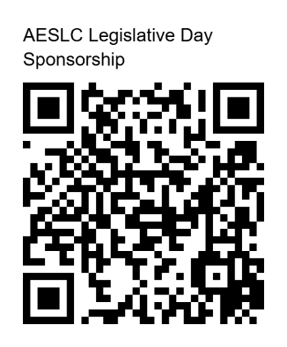

Please email the completed form to mspe@michiganspe.org by April 1, 2026
Sponsorship Deadline April 1

